13 링크(link)와 리다이렉트(redirect)

**링크와 리다이렉트**

**미션**

링크와 리다이렉트를 통해, 페이지간 이동을 연결하시오  
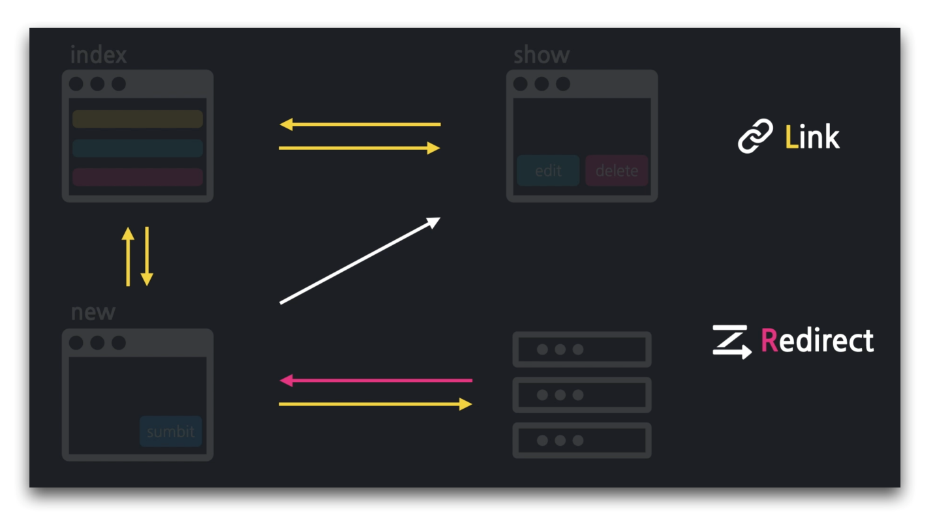

**04:20 목록에서 새 글작성 페이지로**

../articles/index.mustache

1. {{>layouts/header}}
2. <table class="table">
3. ...
4. </table>
5. <a href="/articles/new">New Article</a>
6. {{>layouts/footer}}

**05:33 목록페이지로 돌아가기**

../articles/new.mustache

1. {{>layouts/header}}
2. <form class="container" action="/articles/create" method="post">
3. ...
4. <button type="submit" class="btn btn-primary">Submit</button>
5. <a href="/articles">Back</a>
6. </form>
7. {{>layouts/footer}}

**06:50 리다이렉트 - 새 글저장 후, 상세 페이지로!**

../controller/ArticleController

1. ...
2. @Controller
3. @Slf4j
4. public class ArticleController {
5. ...
6. @PostMapping("/articles/create")
7. public String createArticle(ArticleForm form) {
8. log.info(form.toString());
9. Article article = form.toEntity();
10. log.info(article.toString());
11. Article saved = articleRepository.save(article);
12. log.info(saved.toString());
13. // 리다이렉트 적용: 생성 후, 브라우저가 해당 URL로 재요청
14. return "redirect:/articles/" + saved.getId();
15. }
16. ...
17. }

../entity/Article

1. package com.example.firstproject.entity;
2. import lombok.AllArgsConstructor;
3. import lombok.Getter;
4. import lombok.NoArgsConstructor;
5. import lombok.ToString;
6. import javax.persistence.Column;
7. import javax.persistence.Entity;
8. import javax.persistence.GeneratedValue;
9. import javax.persistence.Id;
10. @Entity
11. @AllArgsConstructor
12. @NoArgsConstructor
13. @ToString
14. @Getter // 롬복으로 게터 추가
15. public class Article {
16. @Id
17. @GeneratedValue
18. private Long id;
19. @Column
20. private String title;
21. @Column
22. private String content;
23. }

**10:52 상세 페이지에서 목록으로**

../articles/show.mustache

1. {{>layouts/header}}
2. <table class="table">
3. ...
4. </table>
5. <a href="/articles">Go to Article List</a>
6. {{>layouts/footer}}

../articles/index.mustache

1. {{>layouts/header}}
2. <table class="table">
3. <thead>
4. <tr>
5. <th scope="col">ID</th>
6. <th scope="col">Title</th>
7. <th scope="col">Content</th>
8. </tr>
9. </thead>
10. <tbody>
11. {{#articleList}}
12. <tr>
13. <th>{{id}}</th>
14. <!-- 제목에 링크 걸기 -->
15. <td><a href="/articles/{{id}}">{{title}}</a></td>
16. <td>{{content}}</td>
17. </tr>
18. {{/articleList}}
19. </tbody>
20. </table>
21. <a href="/articles/new">New Article</a>
22. {{>layouts/footer}}

**🔥 구글링 훈련하기**

* HTML a 태그
* HTTP Redirect란
* @Getter